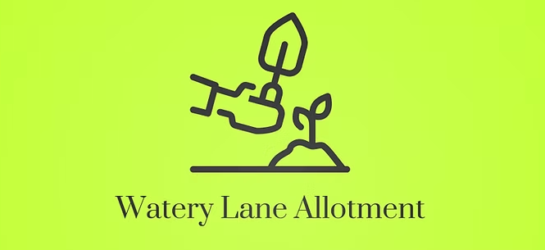
www.watery-lane-allotment.co.uk

Watery Lane Allotments & Leisure Gardens Association
Data Protection Statement
Dated 1st December 2025
The Association is a non-profit making organisation and uses any income solely for the benefit of the Association. As such, the Association is exempt from the requirement to register with the Information Commissioner’s Office in regard to the General Data Protection Regulation (GDPR). The GDRP is designed to increase protection for every individual who provides personal data to an organisation. The Association endeavours to comply with the act by being accountable and transparent in the way it keeps and uses data and undertakes to support the guiding principles of the GDRP.
- All the information held will be relevant to the society.
- The member should give consent by means of a consent form.
- The member should be informed that they have the right to cancel consent at any time.
- The member should be aware of the means by which this information will be kept. The Association propose that their data will be maintained on paper in a secure locked cabinet and on a password protected computer file.
- All information should be kept no longer than necessary, i.e. all information will be deleted on non-renewal of membership or when requested by the member.
- Members should be aware that the personal data provided will only be used by the Association and not passed on to any third party.
- The Association will only use the member’s personal data for the purposes of their involvement in the society.
To this end, the Association Committee approved the following:
Data Controller
The Committee would be the Data Controller; the Data Controller being the person or group of people who determine the purposes for which and the manner in which any Personal Data are, or are to be, processed

Data Processor
Three Data Processors were appointed in relation to Personal Data. These are the committee members who compile and keep the membership list.
Data Subject
The Data Subject is the individuals that a Personal Data relates to and is confined to. The committee agreed this as being the Association membership only.

Agreed at committee meeting
Dated 22nd October 2025

